

INDUSTRIAL CUM SOFTWARE TRAINING REPORT
SUBMITTED IN PARTIAL FULFILLMENT OF THE DEGREE
OF
BACHELOR OF TECHNOLOGY
IN
COMPUTER SCIENCE AND ENGINEERING
SUBMITTED BY
NAME: RAJU KUMAR
ROLL NUMBER: 2339281

Under the Guidance of:
Faculty Mentor Name: Er. Manpreet kaur
Designation: Assistant Professor
Department: Computer Science & Engineering
Organization: Gulzar Group of Institutes

GULZAR GROUP OF INSTITUTES, LUDHIANA, PUNJAB



BTCS801-18] SOFTWARE TRAINING
TRAINING REPORT
UNDERTAKEN AT
FUTURE FINDER PVT. LTD
JANUARY 2026 TO JUNE 2026
ON
RECRUITMENT DASHBOARD ANALYSIS

SUBMITTED IN PARTIAL FULFILLMENT OF THE DEGREE
OF
BACHELOR OF TECHNOLOGY
IN
COMPUTER SCIENCE AND ENGINEERING
SUBMITTED BY

NAME: RAJU KUMAR & ROLL NUMBER: 2339281

Under the Guidance of:
Mentor Name: Er. Manpreet kaur Supervisor Name:MR. Rohan Kashyap
Designation: Assistant Professor Designation: Data Science Developer
Department: CSE Department: Data Analyst

GULZAR GROUP OF INSTITUTES, LUDHIANA, PUNJAB

DECLARATION
I hereby declare that the project work entitled (“Recruitment Dashboard Analysis”) is an authentic record of my own work carried out at (Place of work) as requirements of four months Industrial Training for the award of degree of B.Tech Computer Science and Engineering, Gulzar Group of Institutes, Ludhiana, under the guidance of MR.Rohan Kashyap and Er.Manpreet kaur, during January 2026 to June,2026.

I hereby declare that the above statement made by me is correct to the best of our knowledge and belief
(Signature of student)
Raju Kumar
(2339281)
Date:__________________

Abstract
The Recruitment Dashboard Analysis project is designed to provide a comprehensive and interactive solution for analyzing recruitment and hiring data within an organization. The primary objective of this project is to transform raw recruitment data into meaningful insights that help Human Resource (HR) teams and management make informed hiring decisions. This dashboard utilizes data visualization and business intelligence techniques to monitor key recruitment metrics such as total applications received, number of candidates shortlisted, interviews conducted, offers extended, successful hires, recruitment sources, department-wise hiring, and hiring trends over time. By presenting recruitment data in a visually appealing and easy-to-understand format, the dashboard enables stakeholders to quickly identify patterns, measure recruitment efficiency, and evaluate the effectiveness of different hiring channels. The project is developed using Power BI, which allows dynamic filtering, interactive reporting, and real-time data analysis. Various charts, graphs, KPIs, and performance indicators are incorporated to provide a clear overview of the recruitment process. The dashboard helps organizations reduce hiring time, optimize recruitment costs, improve candidate selection strategies, and enhance overall workforce planning. Through data-driven decision-making, the Recruitment Dashboard Analysis project contributes to improving recruitment performance and organizational productivity. It serves as a valuable tool for HR professionals, recruiters, and management teams by offering actionable insights that support strategic talent acquisition and effective human resource management.

i
Acknowledgement

I would like to express my sincere gratitude to all those who have contributed to the successful completion of my project titled "Recruitment Dashboard Analysis." First and foremost, I would like to thank my project guide and faculty members for their valuable guidance, encouragement, and continuous support throughout the development of this project. Their expertise and constructive suggestions helped me understand the concepts of data analytics, business intelligence, and dashboard development more effectively. I am also thankful to my institution and department for providing the necessary resources, facilities, and learning environment required for carrying out this project successfully. I would like to extend my gratitude to all the individuals and organizations whose datasets, research materials, and online resources helped me gain a deeper understanding of recruitment analytics and data visualization techniques. Their contributions played a significant role in the completion of this work. Special thanks to my friends and classmates for their cooperation, motivation, and valuable discussions that helped me overcome challenges during the project. Finally, I express my heartfelt appreciation to my family for their constant support, encouragement, and patience throughout the project duration. Their confidence in me has been a source of inspiration and strength. This project has provided me with practical knowledge of recruitment analytics, data visualization, and Power BI dashboard development, and I am grateful to everyone who contributed directly or indirectly to its successful completion.

ii

TABLE OF CONTENTS
Abstract………………………………………………………………………….………….…i
Acknowledgments……………………………………………………………………….....…ii
Table of contents…………………………………………………….……………………iii-iv
List of Figure……………………………………………………………………....…………..v
List of table……………………………………………………………….….….….……......vi
Chapter 1: Profile of Institute………………………………………………….………..1-6
1.1 Introduction to Future Finder……………………….……………………………………..1
1.2 Vision and Mission………………………………………………………………………..1
1.3 Institute at a Glance………………………………………………….……………………2
1.4 Location and Infrastructure……………………………………………………………….2
1.5 Courses and Training Programs Offered………………………………………………….3
1.6 Achievements and Recognition…………………………………………………………...3
1.7 Training Methodology………………………………………………………………….....4

Chapter 2: Introduction…………………………………………………………………7-13

2.1 Introduction to Recruitment Dashboard Analysis……………………..………..7

2.1.1 Overview of Recruitment Management…………………………………........7

2.1.2 Challenges in Traditional Recruitment Process………………………………..8

2.1.3 Need for Data-Driven Recruitment………………………………………....8-9

2.1.4 Role of Business Intelligence in Recruitment………………………… …….9

2.1.5 Introduction to Power BI………………………………………………… …..10

2.1.6 Recruitment KPIs and Metrics…………………………………… …….10-11

2.2 Applications of Recruitment Dashboard………………………………………..11

2.2.1 Candidate Tracking and Monitoring………………………………………...11

2.2.2 Recruitment Performance Analysis…………………………………………12

2.2.3 Hiring Source Effectiveness………………………………………………...12

2.2.4 Workforce Planning…………………………………………………………12

2.2.5 HR Decision Support System……………………………………………….12

2.3 Objectives of the Project……………………………………………………….12

2.4 Motivation……………………………………………………………………...12-13

Chapter 3: Literature Survey……………………………………………………….14-16

3.1 Overview of Previous Research………………………………………………..14

3.2 Recruitment Analytics Studies…………………………………………………14

3.3 Dashboard and Data Visualization Research…………………………………..15

3.4 Findings from Literature Survey……………………………………………….16

Chapter 4: Existing Work & Implementation Work………………………………17-24

4.1 Existing Recruitment Analysis Methods……………………………………….17-19

4.2 Limitations of Existing Systems……………………………………………….19-20

4.3 Proposed Recruitment Dashboard System……………………………………..20-21

4.4 Dashboard Design and Architecture…………………………………………..21-22

4.5 Implementation Methodology…………………………………………………22-24

Chapter 5: Dataset, Implementation and Results…………………………………25-38

5.1 Dataset Description…………………………………………………………….25-27

5.2 Data Cleaning and Transformation…………………………………………….27-28

5.3 Tools and Technologies Used………………………………………………….28-30

5.3.1 Power BI

5.3.2 Microsoft Excel

5.3.3 Data Modeling

5.3.4 DAX Functions

5.4 Dashboard Development……………………………………………………….30-32

5.5 Key Performance Indicators (KPIs)…………………………………………..32-33

5.6 Dashboard Visualizations……………………………………………………...33-35

5.6.1 Hiring Trend Analysis

5.6.2 Department-wise Recruitment Analysis

5.6.3 Candidate Status Analysis

5.6.4 Recruitment Source Analysis

5.6.5 Offer Acceptance Rate Analysis

5.7 Results and Findings…………………………………………………………...35-38

Chapter 6: Conclusion and Future Scope………………………………………....39-40

6.1 Conclusion……………………………………………………………………..39

6.2 Future Scope…………………………………………………………………...40

References…………………………………………………………………………..41-42

LIST OF FIGURES

Figure No. | Figure Title | Page No.
Figure 2.1 | Recruitment Dashboard Analysis | 14
Figure 3.1 | Recruitment Data Overview Dashboard | 17
Figure 3.2 | Recruitment Data Mapping Interface | 18
Figure 4.1 | Recruitment Dataset in Excel | 22
Figure 4.2 | Data Cleaning and Transformation | 24
Figure 4.3 | Dashboard Visualization Report | 25
Figure 4.4 | Hiring Trend Analysis Chart | 29
Figure 5.1 | HR KPI Dashboard | 30
Figure 5.2 | Recruitment Performance Dashboard | 36
Figure 5.3 | Recruitment Analytics Dashboard | 37
Figure 6.1 | HR Analytics Interface | 43
Figure 6.2 | Mobile Recruitment Dashboard | 48

LIST OF TABLES
Table No. | Table Title | Page No.
Table 4.1 | Software and Hardware Requirements | 24
Table 6.1 | Advantages of Recruitment Dashboard Analysis | 43

CERTIFICATION OF INDUSTRIAL TRAINING

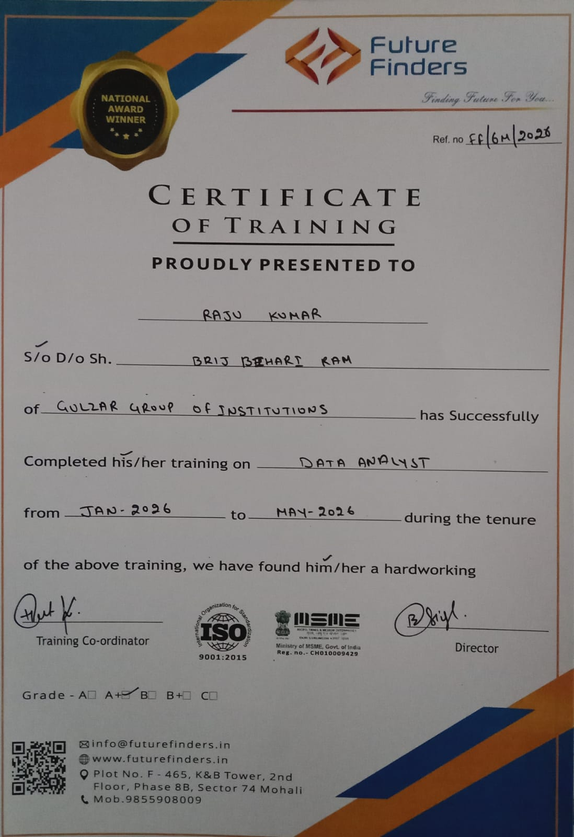
vii

Chapter 1

Profile of Institute
1.1 Introduction to Future Finder
Future Finder is a professionally managed IT training and career development institute located in Mohali, Chandigarh. Established with a clear mission to bridge the gap between academic education and industry-ready skills, Future Finder has emerged as a trusted name in the technology training landscape of the Tricity region (Chandigarh, Mohali, and Panchkula). The institute specialises in providing practical, project-based training in domains such as Artificial Intelligence, Machine Learning, Python programming, Web Development, and Data Science. It caters to engineering students, graduates, and working professionals seeking to upgrade their technical competencies and enhance their employability in the competitive IT sector.
Future Finder has successfully mentored hundreds of students from leading engineering institutions across Punjab and Haryana, including partnerships with universities affiliated to Punjab Technical University (PTU) and Chandigarh University. The institute follows a hands-on, industry-aligned training methodology where each student is assigned a real-world project from the outset, ensuring that theoretical concepts are immediately reinforced through practical implementation.

1.2 Vision and Mission 1.2.1 Vision
To be the most impactful technology training institute in North India, producing industry-ready professionals who can confidently contribute to the rapidly evolving global IT ecosystem.
1.2.2 Mission
To empower students with hands-on technical skills, mentorship from industry practitioners, and exposure to real-world projects, enabling them to secure meaningful careers in technology and contribute positively to society through innovation.

1.3 Institute at a Glance

Parameter | Details
Name of Institute | Future Finder
Location | Mohali, Chandigarh, Punjab
Type | IT Training & Career Development Institute
Training Domains | AI/ML, Python, Web Development, Data Science, Cloud
Target Audience | Engineering Students, Graduates, Working Professionals
Training Mode | Offline (Lab-Based) and Online
Affiliation / Tie-ups | Punjab Technical University (PTU) affiliated colleges
Placement Assistance | Yes–Resume Building, Mock Interviews, Job Referrals

1.4 Location and Infrastructure
Future Finder is centrally located in Mohali (SAS Nagar), adjacent to Chandigarh–one of India's most well-planned cities and a growing IT hub. The institute is easily accessible from all major sectors of Chandigarh and Mohali via public and private transport, making it convenient for students from across the Tricot region.
The institute is equipped with modern computing laboratories featuring high-performance workstations installed with the latest software tools and development environments. Infrastructure highlights include:
• Dedicated computer labs with uninterrupted high-speed internet connectivity.
• GPU-enabled systems for deep learning and computer vision training sessions.
• A fully stocked digital resource library with access to e-books, research papers, and online course platforms.
• Seminar and presentation rooms for project reviews, industry talks, and technical workshops.
• Individual workstations assigned to each intern for the duration of their training period.

1.5 Courses and Training Programs Offered
Future Finder offers a diverse portfolio of short-term and semester-long training programs designed to meet current industry demands. The curriculum is regularly updated in consultation with industry mentors to ensure relevance and quality.

S. No. | Course / Program | Duration | Mode
1 | Python Programming (Basic to Advanced) | 4–6Weeks | Offline
2 | Artificial Intelligence & Machine Learning | 2–4Months | Offline
4 | Web Development  (HTML, CSS, JS, React) | 2 Months | Offline
5 | Data Science & Data Analytics | 3–6Months | Offline
6 | Database Management (MySQL) | 1 Month | Offline
7 | Cloud Computing (AWS Fundamentals) | 1 Month | Online

1.6 Achievements and Recognition
Since its inception, Future Finder has built a strong reputation for delivering quality training and tangible career outcomes. Key achievements include:
• Successful placement assistance provided to over 85% of trained students in reputed IT
organisations across Chandigarh, Mohali, and beyond.
• Consistently high student satisfaction ratings, with trainees reporting significant improvement in technical confidence and project-building capabilities.
• Recognised as a preferred training partner by multiple B.Tech institutions in Punjab for their mandatory six-month internship programmes.
• Alumni placed in companies including Infosys, Wipro, TCS, HCL, and various Chandigarh- based IT startups working in domains of AI, web development, and cloud services.

3

1.7 Training Methodology
Future Finder follows a structured, project-first training methodology that distinguishes it from conventional coaching institutes. The approach is built on four pillars:
1.7.1 Concept Building
Each training module begins with a thorough conceptual introduction covering theory, algorithms, and real-world context. Instructors use case studies and visual aids to ensure students develop a strong foundational understanding before moving to implementation.
1.7.2 Hands-On Laboratory Sessions
Every concept is immediately followed by guided lab sessions where students implement the concepts
on real datasets and development environments. This ensures active learning and immediate application of knowledge.
1.7.3 Live Project Assignment
Students are assigned industry-relevant projects from the beginning of their training. For the current batch, projects include domains such as plant disease detection using CNN, sentiment analysis, object detection systems, and e-commerce recommendation engines.

Chapter 2
Introduction

2.1 Introduction to Recruitment Dashboard Analysis

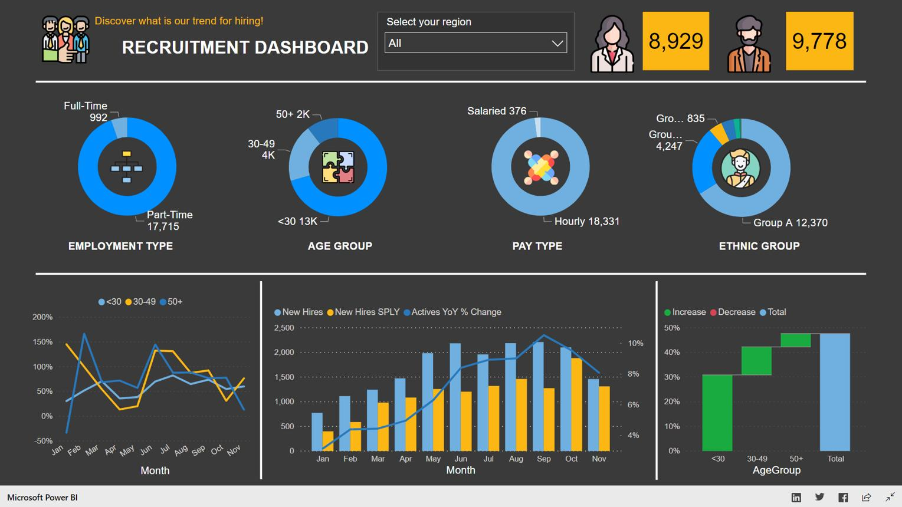
4
Recruitment Dashboard Analysis is a business intelligence solution designed to monitor, evaluate, and improve the recruitment process within an organization. In today's competitive business environment, organizations receive thousands of job applications from candidates across different platforms. Managing and analyzing this large volume of recruitment data manually is time-consuming and prone to errors. A Recruitment Dashboard provides a centralized platform where Human Resource (HR) professionals can track recruitment activities, monitor hiring performance, and gain valuable insights from recruitment data. Using interactive visualizations, charts, and Key Performance Indicators (KPIs), organizations can evaluate hiring efficiency, candidate conversion rates, recruitment source effectiveness, and overall workforce planning. This project utilizes Power BI to transform raw recruitment data into meaningful insights that support strategic decision-making and improve talent acquisition processes.

4

Table 2.1: Importance of Recruitment Dashboard
Feature | Benefit
Real-time Monitoring | Tracks hiring activities instantly
Data Visualization | Simplifies complex recruitment data
KPI Analysis | Measures recruitment performance
Better Decision Making | Supports strategic hiring
Cost Reduction | Optimizes recruitment expenses

2.1.1 Overview of Recruitment Management
Recruitment Management refers to the systematic process of attracting, screening, selecting, and hiring qualified candidates for organizational positions. The recruitment process begins with identifying workforce requirements and creating job descriptions. Organizations then advertise job vacancies through various recruitment channels such as job portals, company websites, social media platforms, and employee referrals. After receiving applications, candidates are shortlisted based on predefined criteria and invited for interviews. Successful candidates receive job offers and are onboarded into the organization. Effective recruitment management ensures that organizations hire the right talent at the right time while minimizing recruitment costs and improving employee retention. Recruitment dashboards help HR managers monitor every stage of this process and identify areas for improvement.

2.1.2 Challenges in Traditional Recruitment Process
Traditional recruitment methods often rely on spreadsheets, paper records, emails, and manual reporting systems. These approaches create several challenges for HR departments. Manual data management can lead to errors, duplication, and inconsistency in recruitment records. HR professionals may struggle to track candidate progress, recruitment timelines, and hiring performance across multiple departments. Reporting and performance analysis become time-consuming, making it difficult to identify recruitment bottlenecks. Additionally, organizations may lack visibility into recruitment costs, candidate sources, and hiring effectiveness. As businesses grow, managing recruitment data manually becomes increasingly complex, highlighting the need for automated dashboard-based solutions.

Table 2.2: Traditional vs Dashboard-Based Recruitment
Traditional Recruitment | Dashboard-Based Recruitment
Manual Reporting | Automated Reporting
Time Consuming | Real-Time Insights
High Error Rate | Accurate Data Analysis
Limited Visualization | Interactive Dashboards
Difficult Tracking | Easy Candidate Tracking

2.1.3 Need for Data-Driven Recruitment
Modern organizations increasingly rely on data-driven recruitment strategies to make informed hiring decisions. Data-driven recruitment uses historical and real-time recruitment data to evaluate hiring performance, identify trends, and improve recruitment outcomes. Instead of relying solely on intuition, HR professionals can analyze measurable indicators such as time-to-hire, cost-per-hire, offer acceptance rates, and source effectiveness. By utilizing data analytics, organizations can identify the most successful recruitment channels, predict hiring requirements, and optimize workforce planning. Data-driven recruitment improves hiring quality, reduces recruitment costs, and increases organizational productivity.

2.1.4 Role of Business Intelligence in Recruitment
Business Intelligence (BI) plays a critical role in transforming recruitment data into actionable insights. BI tools such as Power BI collect, organize, analyze, and visualize recruitment data from multiple sources. Through interactive dashboards, HR managers can monitor key recruitment metrics and identify performance trends. Business Intelligence enables organizations to measure recruitment effectiveness, compare departmental hiring performance, and forecast future hiring needs. The use of BI enhances transparency, improves reporting accuracy, and supports evidence-based decision-making within HR departments.

Figure 2.2: Business Intelligence Framework
Data Collection
↓
Data Cleaning
↓
Data Modeling
↓
Dashboard Creation
↓
Insights & Decision Making

2.1.5 Introduction to Power BI
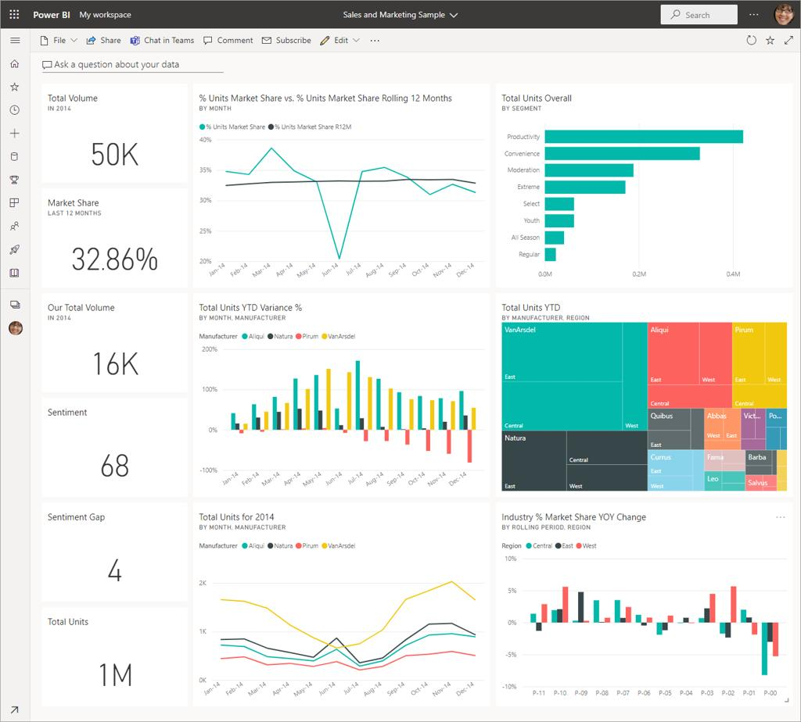

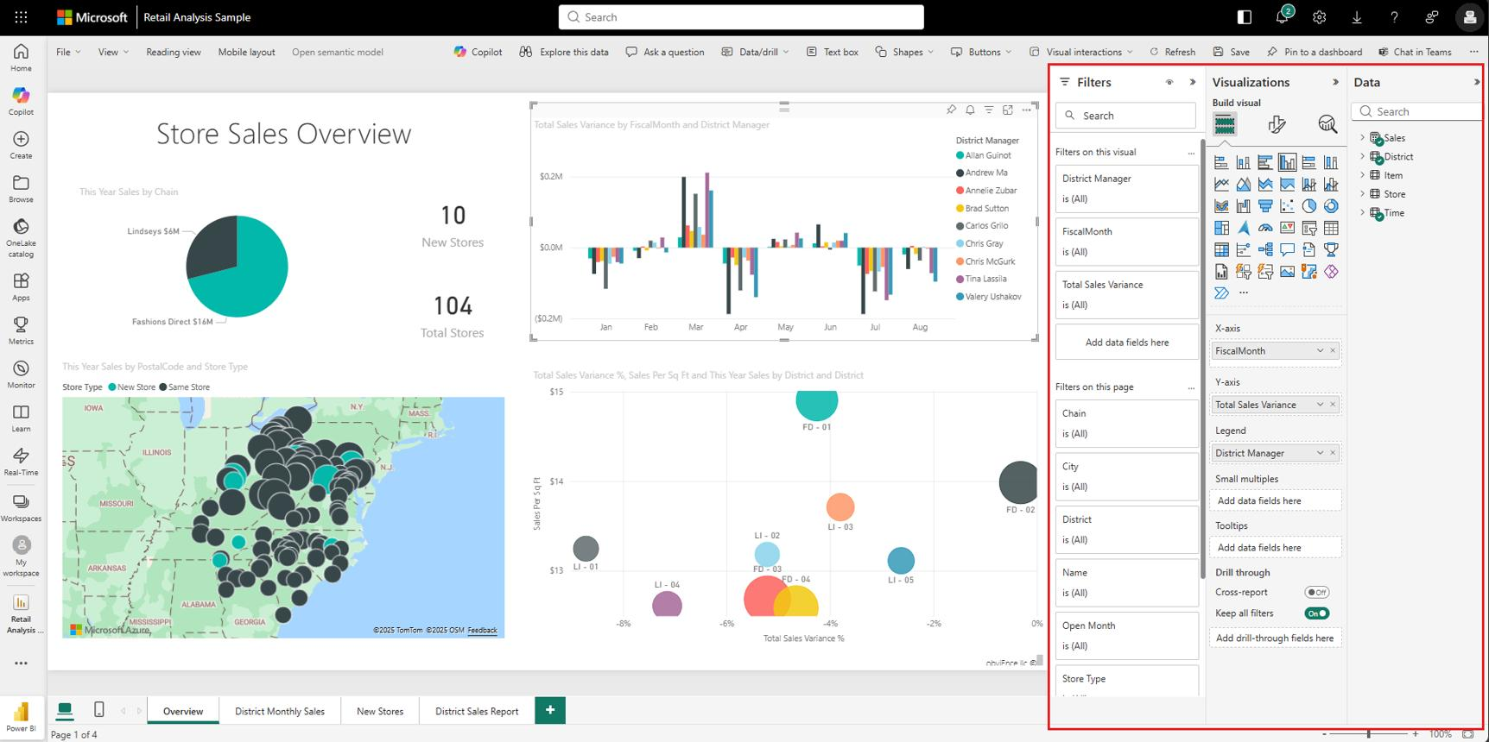
6
Power BI is a powerful business intelligence and data visualization tool developed by Microsoft Corporation. It enables users to connect multiple data sources, transform data, create interactive dashboards, and generate meaningful reports. Power BI provides various visualization options including charts, graphs, maps, tables, and KPI cards that help users understand complex data easily. In this project, Power BI is used to analyze recruitment data and create an interactive dashboard that provides insights into hiring trends, candidate performance, recruitment sources, and workforce planning. Its user-friendly interface and advanced analytical capabilities make it an ideal tool for recruitment analytics.

2.1.6 Recruitment KPIs and Metrics
Key Performance Indicators (KPIs) are measurable values used to evaluate recruitment performance. Recruitment KPIs help organizations monitor efficiency and identify improvement opportunities. Common recruitment metrics include total applications received, shortlisted candidates, interviews conducted, offers extended, successful hires, cost-per-hire, time-to-fill positions, and offer acceptance rates. These indicators provide valuable insights into recruitment effectiveness and support strategic HR planning. By tracking KPIs through dashboards, organizations can continuously improve hiring outcomes and optimize recruitment processes.

2.2 Applications of Recruitment Dashboard

2.2.1 Candidate Tracking and Monitoring
A Recruitment Dashboard allows HR teams to track candidate progress throughout the hiring lifecycle. Recruiters can monitor application status, interview schedules, assessment results, and final hiring decisions. This improves communication, reduces delays, and enhances candidate experience. Real-time candidate tracking helps organizations manage large applicant pools efficiently and ensures transparency throughout the recruitment process.

2.2.2 Recruitment Performance Analysis
Recruitment dashboards provide detailed insights into recruitment performance by measuring key metrics such as hiring speed, candidate quality, and recruitment efficiency. HR managers can compare recruitment outcomes across departments and identify areas requiring improvement. Performance analysis enables organizations to refine recruitment strategies and achieve better hiring results.

2.3 Hiring Source Effectiveness
Organizations use multiple recruitment channels including job portals, employee referrals, social media, and company websites. Recruitment dashboards analyze source effectiveness by tracking the number of candidates generated, shortlisted, and hired from each source. This analysis helps organizations allocate recruitment budgets efficiently and focus on high-performing hiring channels.

2.2.4 Workforce Planning
Workforce planning involves forecasting future staffing requirements based on organizational goals and market conditions. Recruitment dashboards support workforce planning by analyzing historical hiring trends and predicting future recruitment needs. This enables organizations to maintain optimal staffing levels and prepare for business growth.

2.2.5 HR Decision Support System
Recruitment dashboards function as decision support systems by providing accurate and timely information to HR managers. Through interactive reports and analytics, decision-makers can identify recruitment bottlenecks, optimize hiring strategies, and improve talent acquisition processes. Data-driven decision-making increases recruitment efficiency and organizational competitiveness.

2.3 Objectives of the Project
The primary objective of the Recruitment Dashboard Analysis project is to develop an interactive dashboard that provides comprehensive insights into recruitment activities. The project aims to analyze candidate applications, monitor recruitment KPIs, evaluate hiring performance, identify effective recruitment channels, and support strategic workforce planning. Another objective is to automate recruitment reporting and reduce the time required for manual analysis. The dashboard helps HR professionals make informed decisions and improve recruitment efficiency.

Table 2.6: Project Objectives
Objective | Purpose
Analyze Recruitment Data | Generate insights
Track KPIs | Measure performance
Improve Hiring Efficiency | Reduce hiring time
Support Decision Making | Better recruitment planning
Automate Reporting | Save time and effort

2.4 Motivation
The motivation behind developing the Recruitment Dashboard Analysis project arises from the increasing need for efficient recruitment management in modern organizations. Traditional recruitment systems often generate large volumes of data that are difficult to analyze manually. Organizations require real-time insights into hiring activities, candidate performance, and recruitment effectiveness to remain competitive in today's talent-driven market. The implementation of a Recruitment Dashboard enables HR departments to visualize recruitment data, monitor key metrics, and make evidence-based decisions. This project demonstrates how business intelligence tools such as Power BI can transform recruitment data into actionable insights, helping organizations optimize hiring strategies, reduce recruitment costs, improve candidate selection, and enhance overall workforce management. The project also provides practical experience in data analytics, dashboard design, and business intelligence technologies, making it valuable from both academic and professional perspectives.

Chapter 3

Literature Survey

3.1 Introduction

A literature survey is an important part of any project as it provides a comprehensive review of previous studies, research papers, articles, and existing systems related to the project topic. For the Recruitment Dashboard Analysis project, the literature survey focuses on recruitment analytics, human resource analytics, business intelligence, data visualization, and dashboard-based decision-making systems. The objective of this survey is to understand the current trends, methodologies, tools, and technologies used in recruitment analysis and identify gaps that can be addressed through the proposed dashboard solution. By studying existing research and industry practices, organizations can develop more efficient recruitment strategies and improve hiring outcomes.

3.2 Overview of Recruitment Analytics Research

Recruitment analytics has emerged as a critical component of modern Human Resource Management. Researchers have highlighted the importance of analyzing recruitment data to improve hiring efficiency and workforce planning. Traditional recruitment methods often relied on intuition and manual record keeping, whereas modern recruitment analytics uses data-driven approaches to evaluate hiring performance. Studies suggest that organizations utilizing recruitment analytics can reduce hiring costs, shorten recruitment cycles, and improve candidate quality. Recruitment analytics enables HR managers to track recruitment KPIs such as time-to-hire, cost-per-hire, source effectiveness, and employee retention rates.

3.3 Human Resource Analytics Studies

Human Resource (HR) Analytics refers to the application of data analysis techniques to human resource management processes. Several studies have demonstrated that HR analytics helps organizations understand employee behavior, optimize recruitment strategies, and improve workforce performance. Researchers have emphasized that HR analytics allows organizations to identify recruitment bottlenecks, evaluate candidate quality, and forecast workforce requirements. Through the use of dashboards and reporting systems, HR professionals can gain deeper insights into recruitment trends and employee lifecycle management. The integration of analytics into HR functions has transformed recruitment from an operational activity into a strategic business process.

3.4 Research on Business Intelligence in Recruitment

Business Intelligence (BI) has become one of the most widely adopted technologies in recruitment analytics. Researchers have found that BI tools help organizations transform large volumes of recruitment data into meaningful information. Business Intelligence platforms such as Power BI, Tableau, and Qlik Sense provide advanced reporting and visualization capabilities that support decision-making processes. Studies indicate that BI-driven recruitment systems improve transparency, reduce reporting time, and enhance recruitment effectiveness. Organizations can use BI dashboards to monitor recruitment KPIs, compare departmental hiring performance, and identify areas requiring improvement.

3.5 Research on Dashboard-Based Decision Making

Dashboard-based decision-making systems have gained significant attention in recent years. Research studies have shown that dashboards improve information accessibility and facilitate faster decision-making. Dashboards present complex datasets through visual elements such as charts, graphs, KPI cards, and interactive filters. In recruitment management, dashboards help HR teams monitor hiring progress, evaluate recruitment channels, and measure candidate conversion rates. Researchers have concluded that dashboard-based systems increase operational efficiency and improve organizational performance by providing real-time insights.

3.6 Research on Recruitment KPIs and Performance Metrics

Key Performance Indicators (KPIs) play a crucial role in evaluating recruitment performance. Various studies have identified several recruitment metrics that organizations use to measure hiring success. These include Time-to-Hire, Cost-per-Hire, Offer Acceptance Rate, Source Effectiveness, Candidate Satisfaction, and Employee Retention Rate. Researchers suggest that monitoring these KPIs helps organizations identify inefficiencies in recruitment processes and implement corrective actions. KPI-based dashboards provide recruiters with measurable indicators that support continuous improvement and strategic workforce planning.

3.7 Research on Data Visualization Techniques

Data visualization is an essential component of business intelligence systems. Researchers have emphasized that visual representations of data improve comprehension and facilitate decision-making. Charts, graphs, heat maps, KPI cards, and trend lines help users identify patterns and anomalies within datasets. In recruitment analytics, visualizations allow HR professionals to quickly understand hiring trends, department-wise recruitment performance, and candidate demographics. Studies indicate that interactive visualizations significantly improve user engagement and reporting efficiency.

3.8 Research on Power BI for Recruitment Analytics

Power BI has become one of the most popular business intelligence tools for recruitment analytics. Several researchers and industry experts have demonstrated the effectiveness of Power BI in handling large datasets and generating interactive dashboards. Power BI provides features such as data integration, transformation, modeling, and visualization, making it suitable for HR analytics applications. Studies have shown that Power BI dashboards help organizations improve recruitment transparency, automate reporting, and enhance decision-making capabilities. Its ability to connect with multiple data sources and perform advanced calculations through DAX functions makes it an ideal platform for recruitment analysis

3.9 Findings from Literature Survey

The literature survey reveals that organizations are increasingly adopting data-driven recruitment strategies to improve hiring outcomes. Research studies consistently demonstrate that recruitment analytics, business intelligence, and dashboard technologies enhance recruitment efficiency and support strategic decision-making. Existing studies highlight the importance of monitoring recruitment KPIs and using visualization tools to simplify complex recruitment data. Although several recruitment management systems exist, many organizations still face challenges related to data integration, reporting delays, and limited analytical capabilities. Therefore, the development of a Recruitment Dashboard using Power BI provides a practical solution that addresses these challenges and enables organizations to make informed hiring decisions.

3.10 Research Gap

Despite significant advancements in recruitment analytics, many organizations continue to rely on fragmented reporting systems and manual data analysis techniques. Existing recruitment systems often lack comprehensive visualization features and real-time analytical capabilities. Furthermore, organizations may face challenges in integrating recruitment data from multiple sources into a single platform. The literature survey identifies the need for a centralized, interactive, and user-friendly recruitment dashboard that provides actionable insights through effective data visualization. The proposed Recruitment Dashboard Analysis project aims to bridge this gap by utilizing Power BI to create a comprehensive recruitment analytics.

Chapter 4

Summary

This chapter reviewed previous studies related to recruitment analytics, HR analytics, business intelligence, dashboard systems, KPI monitoring, data visualization, and Power BI. The survey demonstrated that data-driven recruitment approaches significantly improve hiring efficiency and organizational performance. The findings support the development of a Recruitment Dashboard Analysis system that provides real-time insights, interactive visualizations, and strategic decision-making capabilities for HR professionals.

Chapter 5

Dataset, Implementation and Results

5.1 Dataset Details

5.1 Introduction to Dataset
The success of any data analytics project depends on the quality and structure of the dataset used for analysis. In the Recruitment Dashboard Analysis project, the dataset contains recruitment-related information collected from the Human Resource (HR) department. The dataset provides detailed information about candidates, job positions, departments, recruitment sources, interview outcomes, hiring status, and recruitment timelines. This data serves as the foundation for generating meaningful insights and visualizations within the dashboard.The dataset is organized in a structured format and imported into Power BI for analysis. Each record represents a candidate's recruitment journey from application submission to final hiring decision. The collected data enables recruiters and management teams to evaluate recruitment performance and identify opportunities for improvement.

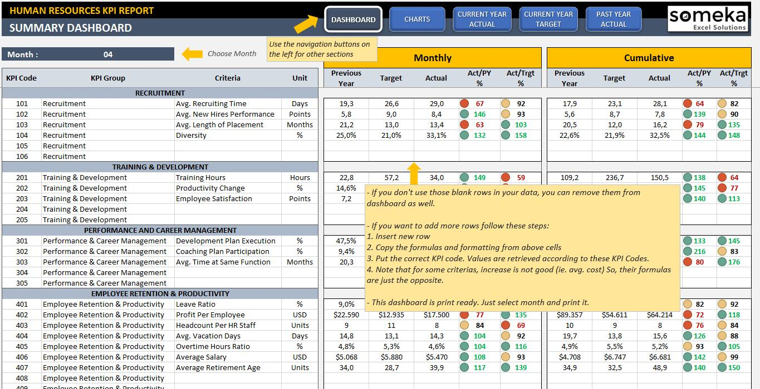
Su

4

Attribute | Description
Candidate ID | Unique identification number

5.1.1 Data Collection Process
The recruitment dataset is collected from various recruitment channels and HR management systems. Data sources may include company career portals, job websites, employee referrals, social media platforms, recruitment agencies, and internal HR databases.The collected data is consolidated into a single dataset to facilitate comprehensive analysis. Proper data collection ensures accuracy, consistency, and reliability of the recruitment dashboard.

5.1.2 Dataset Characteristics
The recruitment dataset contains both categorical and numerical data. Categorical attributes include department names, recruitment sources, interview status, and hiring status. Numerical attributes include hiring costs, number of applicants, and recruitment duration.The dataset may consist of hundreds or thousands of candidate records depending on organizational size. A larger dataset provides better analytical accuracy and enables more reliable trend analysis.

5.2 Data Cleaning and Transformation
Raw recruitment data often contains missing values, duplicate entries, formatting inconsistencies, and incorrect records. Data cleaning is necessary to ensure the accuracy and reliability of analytical results. Poor-quality data can lead to misleading insights and incorrect decision-making.Data cleaning improves data consistency and prepares the dataset for visualization and reporting.

5.2.2 Data Transformation
After cleaning, the dataset undergoes transformation using Power Query in Power BI. Data transformation involves modifying data structures, creating calculated columns, converting data types, and preparing relationships between tables.
Examples:
- Converting date formats.
- Creating month-wise hiring categories.
- Standardizing department names.
- Calculating recruitment durations.

Table 5.3: Data Transformation Activities
Activity | Purpose
Date Conversion | Standardized date analysis
Column Creation | Additional metrics
Data Formatting | Consistent values
Data Filtering | Remove unnecessary records

5.3 Tools and Technologies Used

5.3.1 Microsoft Power BI
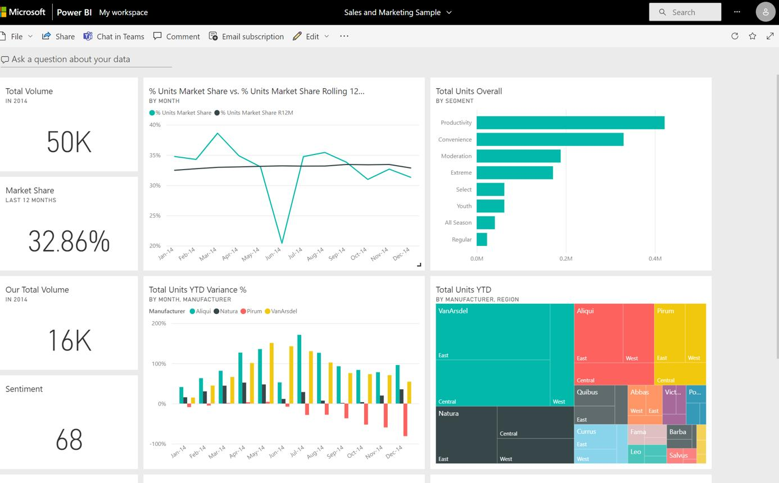
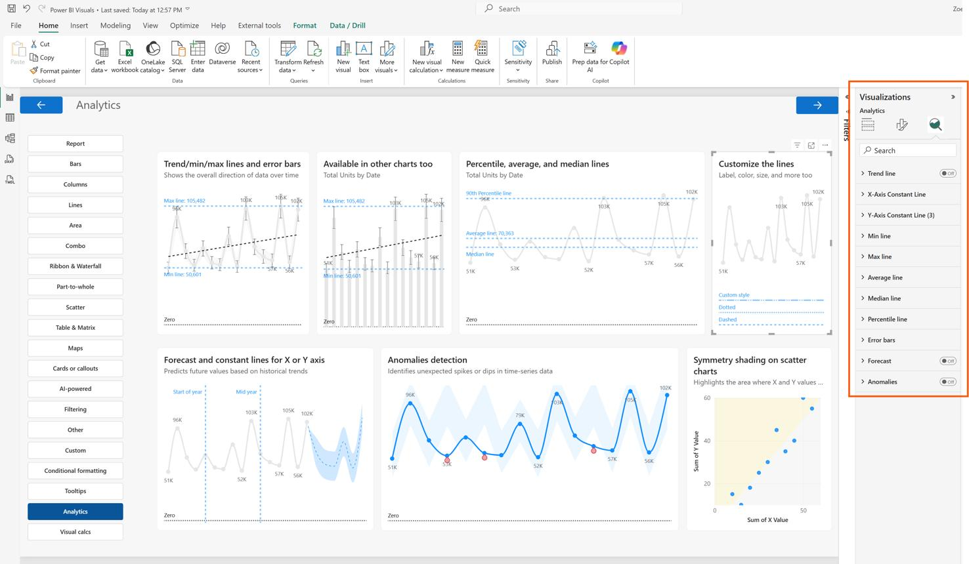
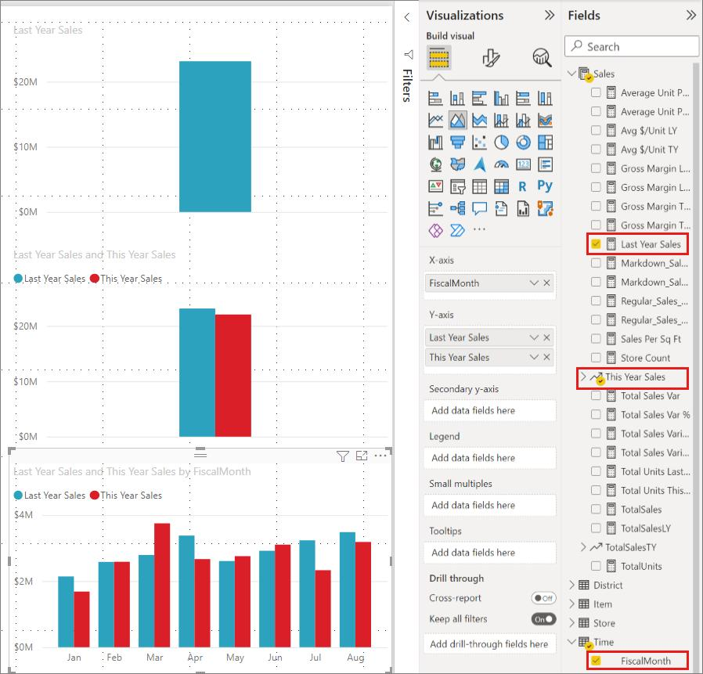
Power BI is the primary tool used for developing the Recruitment Dashboard. It provides advanced data visualization, reporting, and analytical capabilities. Power BI enables users to connect multiple data sources, transform data, create interactive reports, and share dashboards with stakeholders.
The tool offers drag-and-drop functionality, making dashboard development simple and efficient.

5.3.2 Microsoft Excel
Microsoft Excel is used as the primary data storage and preparation tool. Recruitment data is initially maintained in Excel spreadsheets before being imported into Power BI. Excel helps in preliminary data validation and organization.

5.3.3 Power Query
Power Query is used to clean and transform raw recruitment data before analysis. It automates repetitive data preparation tasks and improves data quality.
Import Data
↓
Power Query
↓
Transform Data
↓
Load to Power BI

5.3.4 DAX Functions
Data Analysis Expressions (DAX) are formulas used in Power BI to perform advanced calculations. DAX enables the creation of KPIs and custom measures required for recruitment analysis.
Common DAX calculations include:
- Total Applications
- Total Hires
- Hiring Rate
- Cost-per-Hire
- Offer Acceptance Rate

Table 5.6: Sample DAX Measures
Measure | Purpose
Total Applications | Count applicants
Total Hires | Count selected candidates
Hiring Rate | Recruitment effectiveness
Average Hiring Cost | Cost analysis

5.4 Dashboard Development
The Recruitment Dashboard is developed using a structured approach. The dashboard contains multiple pages and visualizations that provide comprehensive insights into recruitment activities.
Major dashboard components include:
- KPI Cards
- Hiring Trend Analysis
- Department-wise Recruitment Analysis
- Candidate Status Distribution
- Recruitment Source Analysis
- Offer Acceptance Analysis

Figure 5.4: Dashboard Development Process
Dataset
↓
Data Cleaning
↓
Data Modeling
↓
KPI Creation
↓
Visualization Design
↓
Final Dashboard

5.5 Key Performance Indicators (KPIs)
KPIs are essential metrics used to evaluate recruitment performance. The dashboard includes several KPIs that provide quick insights into hiring efficiency.

Important KPIs
- Total Applications Received
- Total Interviews Conducted
- Total Candidates Hired
- Offer Acceptance Rate
- Cost-per-Hire
- Time-to-Hire

Table 5.7: KPI Summary
KPI | Description
Applications | Total received applications
Interviews | Candidates interviewed
Hires | Successful candidates
Acceptance Rate | Accepted offers percentage
Time-to-Hire | Average hiring duration
Cost-per-Hire | Hiring expenditure

5.6 Dashboard Visualizations

5.6.1 Hiring Trend Analysis
Hiring Trend Analysis helps identify recruitment patterns over different months and years. HR managers can evaluate seasonal hiring trends and forecast future workforce requirements.
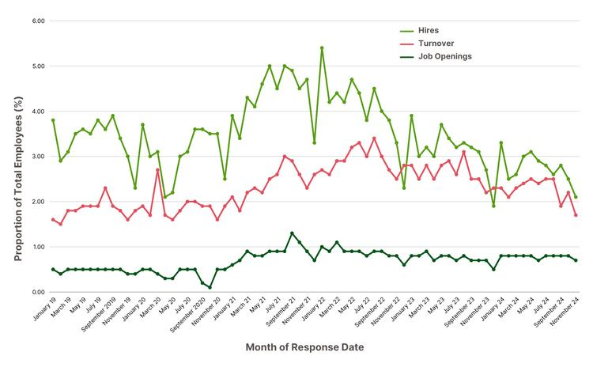
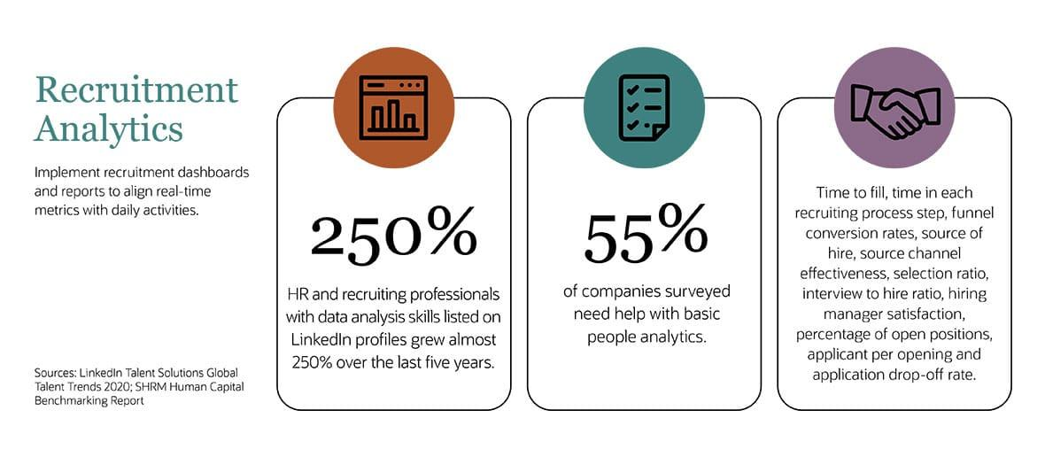
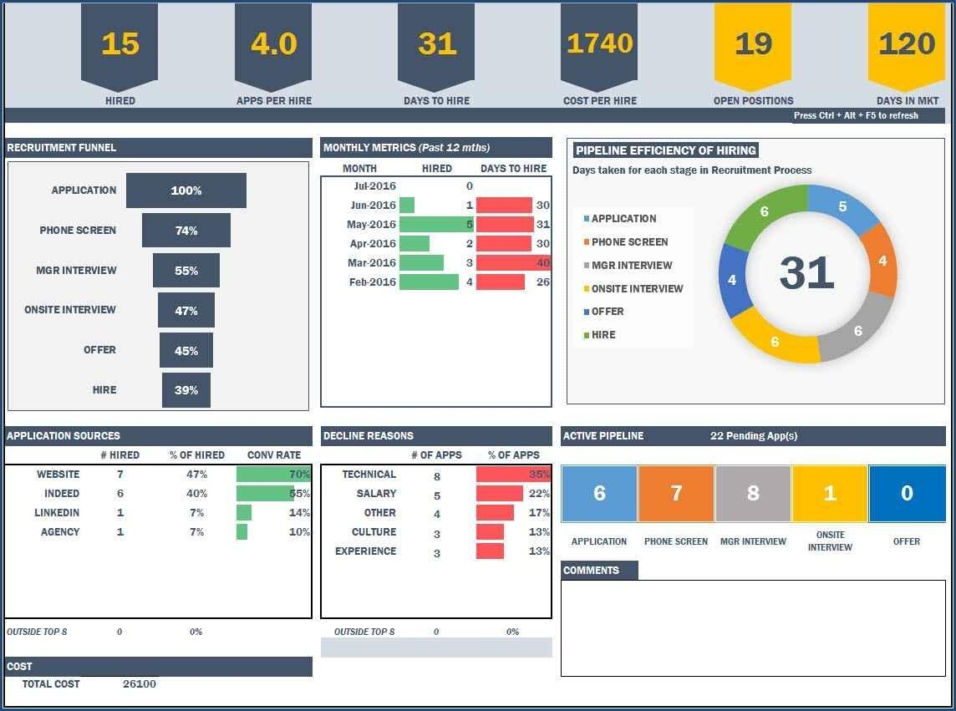

5.6.2 Department-Wise Recruitment Analysis
This visualization compares recruitment performance across different departments. It identifies departments with the highest hiring demand and assists in workforce planning.

5.6.3 Candidate Status Analysis
Candidate Status Analysis categorizes applicants into different stages such as Applied, Shortlisted, Interviewed, Offered, and Hired.

Figure 5.5
Applied
↓
Shortlisted
↓
Interviewed
↓
Offered
↓
Hired

5.6.4 Recruitment Source Analysis
Organizations use multiple recruitment channels. Source Analysis identifies the most effective hiring source.

5.6.5 Offer Acceptance Rate Analysis
Offer Acceptance Rate measures the percentage of candidates who accept job offers. A higher acceptance rate indicates an effective recruitment process and attractive job offerings.

Formula
Offer Acceptance Rate=Accepted OffersTotal Offers×100Offer\ Acceptance\ Rate = \frac{Accepted\ Offers}{Total\ Offers} \times 100Offer Acceptance Rate=Total OffersAccepted Offers​×100

5.7 Results and Findings
The Recruitment Dashboard successfully transforms raw recruitment data into meaningful business insights. The dashboard provides real-time visibility into hiring activities and supports strategic decision-making. Analysis of recruitment KPIs reveals trends in candidate acquisition, interview success rates, departmental hiring patterns, and recruitment source effectiveness.
The findings indicate that employee referrals and company websites often generate high-quality candidates, while hiring trends vary across departments. The dashboard significantly reduces manual reporting effort and improves recruitment transparency.

Chapter 6

Conclusion and Future Scope

6.1 Conclusion

6.1 Introduction
The Recruitment Dashboard Analysis project was developed to address the growing need for data-driven recruitment management in modern organizations. Recruitment is one of the most critical functions of Human Resource Management, and effective hiring decisions directly contribute to organizational success. Traditional recruitment methods often rely on manual reporting, spreadsheets, and fragmented data sources, making it difficult to monitor hiring performance and generate actionable insights. To overcome these challenges, the project utilizes Power BI to create an interactive and visually appealing recruitment dashboard that transforms raw recruitment data into meaningful information.
The dashboard integrates recruitment-related data from multiple sources and presents it through various visualizations, charts, graphs, and Key Performance Indicators (KPIs). This enables HR professionals and management teams to monitor recruitment activities, evaluate hiring efficiency, and make informed decisions based on real-time data.

6.1.1 Achievement of Project Objectives
The primary objective of this project was to develop an interactive Recruitment Dashboard capable of analyzing recruitment performance and providing meaningful insights. The project successfully achieved the following objectives:
- Collection and integration of recruitment data.
- Data cleaning and transformation using Power Query.
- Creation of an optimized data model.
- Development of KPIs for recruitment performance measurement.
- Design of interactive dashboards using Power BI.
- Visualization of hiring trends and recruitment metrics.
- Generation of actionable insights for HR decision-making.
The implemented dashboard provides recruiters with a centralized platform to monitor candidate pipelines, analyze hiring trends, and assess recruitment effectiveness.

Table 6.1: Achievement of Objectives
Objective | Status
Data Collection | Achieved
Data Cleaning | Achieved
KPI Development | Achieved
Dashboard Design | Achieved
Recruitment Analysis | Achieved
Reporting Automation | Achieved

6.1.2 Benefits of the Recruitment Dashboard
The developed dashboard offers several benefits to organizations and HR professionals. By automating recruitment analysis and reporting processes, the dashboard reduces manual effort and increases operational efficiency. Real-time access to recruitment metrics enables HR managers to identify bottlenecks and improve hiring strategies.
The dashboard also improves transparency by providing stakeholders with a clear overview of recruitment performance. Interactive visualizations help users understand complex recruitment data quickly and support evidence-based decision-making.

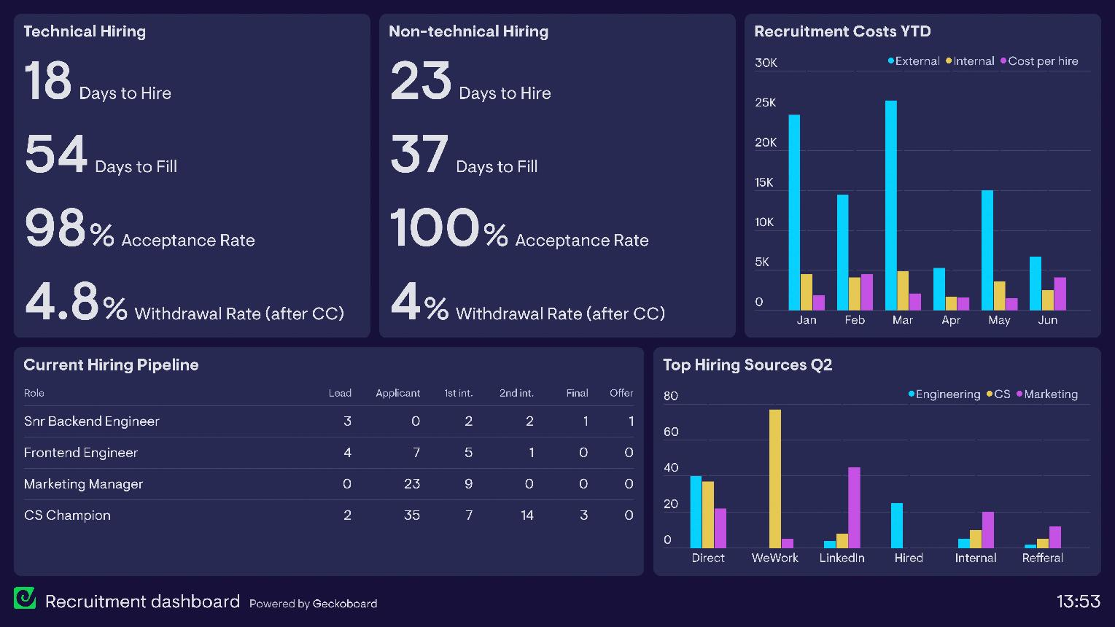
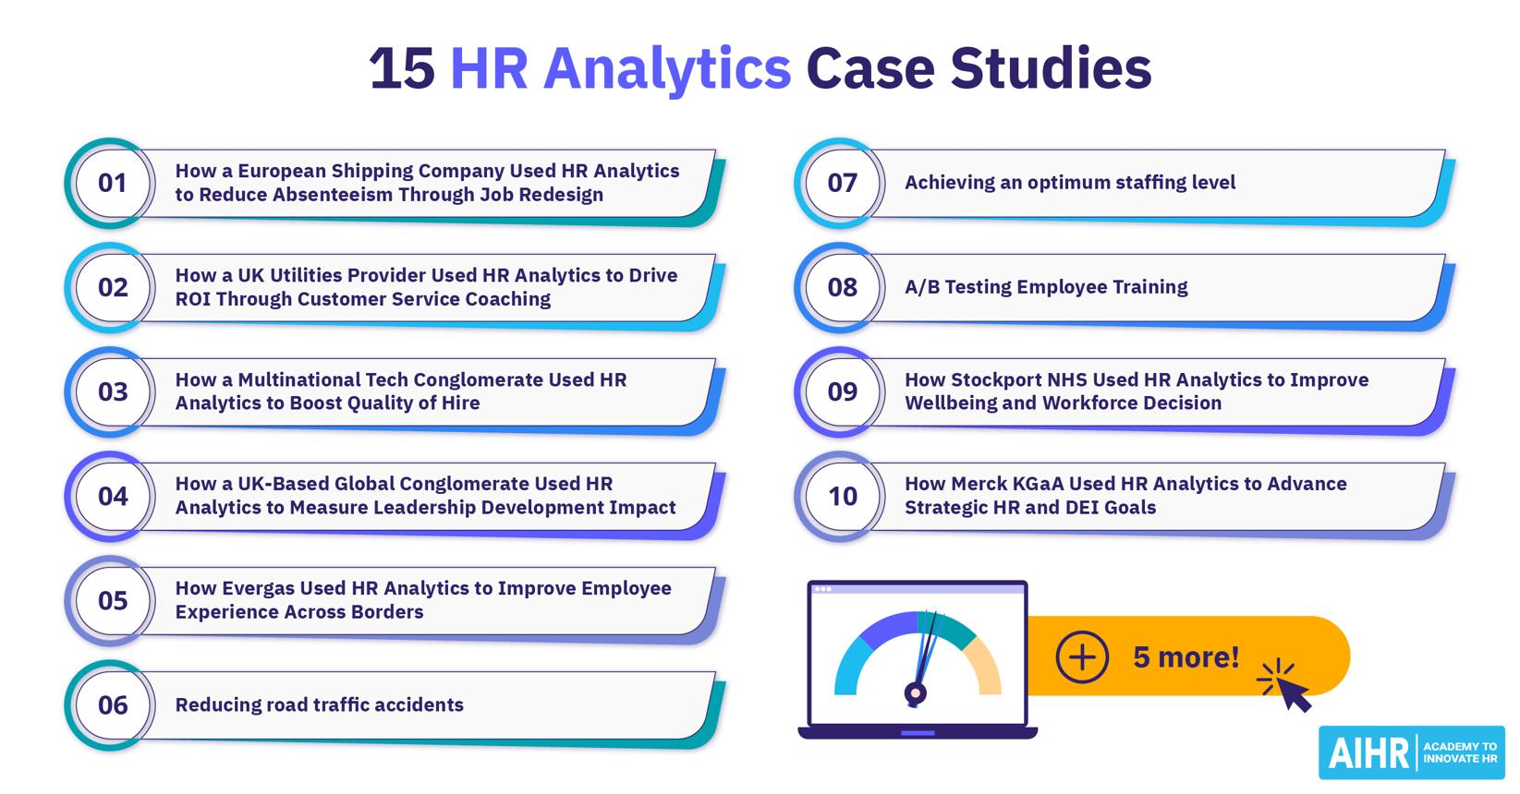

Table 6.2: Benefits of Recruitment Dashboard
Benefit | Description
Real-Time Monitoring | Instant access to recruitment data
Improved Decision Making | Data-driven hiring decisions
Reduced Reporting Time | Automated report generation
Better Visualization | Easy understanding of trends
Enhanced Efficiency | Faster recruitment analysis
Strategic Planning | Supports workforce planning

6.1.3 Key Findings from the Analysis
The Recruitment Dashboard Analysis generated several important findings regarding organizational hiring practices. The analysis revealed recruitment trends, candidate conversion rates, department-wise hiring performance, and source effectiveness.
Some major observations include:
- Certain recruitment channels generated higher-quality candidates.
- Employee referrals often showed better hiring success rates.
- Some departments experienced higher recruitment demand than others.
- Offer acceptance rates provided insights into candidate satisfaction.
- Recruitment KPIs helped identify opportunities for process improvement.
These findings demonstrate the value of recruitment analytics in optimizing hiring strategies and improving recruitment outcomes.

6.1.4 Impact on Human Resource Management
The implementation of recruitment analytics has significantly transformed Human Resource Management. Instead of relying on intuition and manual reports, HR professionals can now use analytical insights to support hiring decisions. Recruitment dashboards facilitate performance monitoring, workforce planning, and resource allocation.
The project demonstrates how Business Intelligence tools can bridge the gap between operational recruitment activities and strategic HR planning. Organizations can use recruitment analytics to align hiring practices with business objectives and improve overall workforce quality.

Figure 6.1: Recruitment Analytics Impact
Recruitment Data
↓
Analytics & KPIs
↓
Dashboard Insights
↓
HR Decisions
↓
Improved Hiring Outcomes

6.2 Future Scope

6.2.1 Introduction to Future Scope
Although the Recruitment Dashboard Analysis project successfully provides valuable insights into recruitment performance, there are several opportunities for future enhancement. With advancements in Artificial Intelligence (AI), Machine Learning (ML), and Predictive Analytics, recruitment systems can become more intelligent and proactive.
Future improvements can enhance dashboard functionality, automate recruitment processes, and provide predictive hiring recommendations.

6.2.2 Integration with Artificial Intelligence
Artificial Intelligence can significantly improve recruitment analytics by automating candidate screening and recommendation processes. AI algorithms can analyze candidate resumes, identify suitable candidates, and rank applicants based on predefined criteria.
AI-powered recruitment systems can reduce recruiter workload and improve hiring accuracy by minimizing human bias.



6.2.3 Predictive Recruitment Analytics
Predictive Analytics uses historical recruitment data to forecast future hiring requirements and recruitment trends. Future versions of the dashboard can incorporate predictive models to estimate:
- Future staffing requirements.
- Candidate demand trends.
- Recruitment costs.
- Hiring success probabilities.
Predictive recruitment analytics can help organizations proactively plan workforce requirements and allocate resources effectively.

6.2.4 Real-Time Data Integration
The current dashboard primarily relies on periodic data updates. Future enhancements may include real-time integration with Human Resource Information Systems (HRIS), Applicant Tracking Systems (ATS), and online recruitment platforms. Real-time data integration will ensure that recruitment insights remain current and support faster decision-making.

6.2.5 Mobile Dashboard Accessibility
As organizations increasingly adopt mobile technologies, future recruitment dashboards can be optimized for smartphones and tablets. Mobile accessibility enables recruiters and managers to monitor recruitment performance anytime and anywhere.
Mobile dashboards improve flexibility, responsiveness, and user convenience.
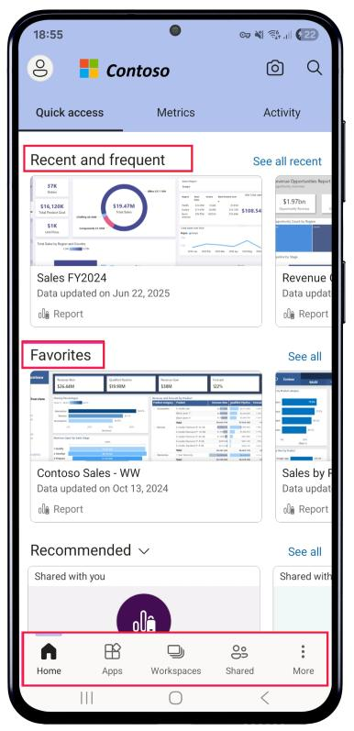

6.2.6 Advanced KPI Monitoring
Future versions of the dashboard can include additional KPIs and advanced performance metrics. Examples include:
- Quality of Hire.
- Candidate Satisfaction Score.
- Diversity Hiring Metrics.
- Employee Retention Rate.
- Recruitment ROI.
Advanced KPIs provide deeper insights into recruitment effectiveness and organizational performance.

6.2.7 Cloud-Based Recruitment Analytics
Cloud computing technologies can further enhance recruitment analytics systems. Cloud-based dashboards provide scalability, accessibility, and collaboration capabilities. Organizations can securely access recruitment reports from any location and share insights across departments.
Cloud deployment also supports large-scale data processing and real-time analytics.

Figure 6.3: Cloud-Based Recruitment Analytics
Recruitment Data
↓
Cloud Storage
↓
Power BI Service
↓
Interactive Dashboard
↓
Anywhere Access

6.3 Overall Project Summary
The Recruitment Dashboard Analysis project successfully demonstrates the application of Business Intelligence and Data Analytics in Human Resource Management. By utilizing Power BI, the project transforms recruitment data into actionable insights through interactive dashboards and KPI monitoring.
The system improves recruitment transparency, enhances decision-making, and supports strategic workforce planning. Through effective visualization and analytical capabilities, the dashboard enables organizations to optimize hiring processes and improve recruitment outcomes.
The project highlights the growing importance of data-driven recruitment and provides a strong foundation for future enhancements involving Artificial Intelligence, Machine Learning, Predictive Analytics, and Cloud Computing.

REFERENCES

Books
[1] Kothari, C. R., Research Methodology: Methods and Techniques, New Age International Publishers, 2nd Edition, 2004.
[2] Laudon, K. C., and Laudon, J. P., Management Information Systems: Managing the Digital Firm, Pearson Education, 16th Edition, 2020.
[3] Sharma, S., Business Analytics Using Microsoft Power BI, BPB Publications, 2022.
[4] Turban, E., Sharda, R., and Delen, D., Business Intelligence and Analytics: Systems for Decision Support, Pearson Education, 10th Edition, 2018.
[5] Foster Provost and Tom Fawcett, Data Science for Business, O'Reilly Media, 2013.

